NINJA HOP 2.0

Author:Jon Alberdi
Date:15/03/2024

INDEX

Introduction
This document presents the final project for the Higher Vocational Training Course in Multiplatform Application Development at Uni Eibar. The project focuses on enhancing a previously developed game during the course called "Ninja Hop," which is a platform-style game created with Unity.

The main objective of this project is to redesign some levels of the game to make them more engaging and to improve the implementation of certain gameplay mechanics. Additionally, dialogue between characters will be added to enrich the game's narrative. Furthermore, graphical improvements will be made to enhance the visual quality of the game.

This project combines technical skills in multiplatform application development with the creativity required for level design and game narrative. Through this process, the aim is to significantly enhance the user experience in the "Ninja Hop" game, providing a more comprehensive and appealing final product.

PROJECT CONTEXT
The project takes place in a context marked by the growing importance of entertainment in the video game market. In recent years, we have witnessed a significant increase in the popularity of video games as a form of entertainment, both for casual players and more dedicated enthusiasts. This growth has been partly driven by the success of numerous independent developers and game development studios that have produced innovative and engaging games.

Many of today's prominent programmers and renowned studios began their journey by developing and publishing small indie games that captured players' imaginations. This phenomenon highlights the importance of creativity and innovation in the world of video games, where even the most modest projects can have a significant impact on the industry.

With a clear understanding of the potential of the video game market and my intention to work in this sector in the future, this project takes on special importance. My goal is to enhance the "Ninja Hop" game so that, despite being a small-scale game, it can attract players and offer an immersive and satisfying gaming experience.

This project represents an opportunity for me to professionalize and improve my skills in game development. Through the process of redesigning levels, adding character dialogues, and graphical enhancements, I aim to elevate the quality of the game and create a final product that reflects my professional aspirations and commitment to excellence in game development.

OBJECTIVES
I would like to divide the objectives of this project into two parts: the objectives related to the project itself and what I aim to achieve by working on it, and the personal objectives.
Regarding the project, through level redesign, my goal is to enhance the player experience by creating well-thought-out levels that introduce all the mechanics used in the final boss beforehand, thus avoiding an overload of new information in the last level. Additionally, I plan to add narrative elements to enrich the game and increase user enjoyment. Lastly, I intend to improve certain graphical aspects to make them more understandable for the player and aesthetically pleasing.
As for my personal objectives, I aim to continue improving in the field of game development. In the first version of the project, I focused mainly on game mechanics, but in this project, I want to concentrate on other aspects to have the opportunity to work in all areas and discover which one I enjoy the most. Furthermore, I would like to work on all fronts to refine the game and strive to achieve a product that feels complete.

resources
Human Resources:
Game Developer: Responsible for implementing the changes and improvements in the game.
Level Designer: In charge of redesigning the game levels to enhance gameplay and user experience.
Dialogue Writer: Responsible for creating character dialogues that enrich the game's narrative.
Graphic Designer: Responsible for enhancing the visual and graphic designs of the game.
Development Equipment:

Computers: Necessary for game development and testing.
Game development software: Such as Unity or other game design programs.
Graphic design tools: Simple tools like Microsoft Paint may suffice for the limited design modifications required.
Other Resources:

Distribution services: In case of publishing the game, distribution services like Steam would be necessary instead of storage services.
Additional resources specific to the project, such as sound libraries or additional design resources, may not be required as existing assets can be modified instead.
Mobile devices: Not necessary for the project since the game is for computers, not mobile platforms.

ANALYSIS OF THE COMPUTER APPLICATION

OBJECTIVE ANALYSIS
The game aims to provide a challenging yet enjoyable platforming experience for players. However, the current level design lacks effective progression and introduces new mechanics abruptly, leading to frustration. The objective analysis involves identifying these shortcomings and devising strategies to address them, such as refining level progression and introducing mechanics gradually to enhance player engagement and enjoyment. Additionally, the introduction of a simple yet compelling narrative will add depth to the gaming experience, further enhancing player immersion and motivation to progress through the game.

TEKNOLOGI-PLATAFORM
The game is developed using Unity for computer platforms. This choice of technology allows for flexibility in development and deployment across various computer systems. The technological aspects of the game include considerations for graphical improvements and optimization, ensuring smooth performance across different computer configurations. Additionally, while music is not a priority, implementing sound effects effectively within the Unity framework enhances the overall gaming experience.

Overview:

The game is a platformer developed in Unity for computers, where players have various options: they can play all levels consecutively, play levels separated by difficulty, or play all levels consecutively with a timer to track their completion time. The main character is a ninja frog.

Game Mechanics:

Movement: The main mechanic allows players to move and jump using different keys for comfortable gameplay.

Weapon: Players can pick up a weapon to kill enemies and activate buttons to unlock parts of the map.

Level Restart: Players can restart the level by pressing "R."

Main Menu: Players can return to the main menu from any level by pressing "ESC."

Map: Players can open a map by pressing "M" to navigate through the last level.

Invencibility: Players can become invincible by pressing "I" to pass the final boss without dying.

Level Design:

The level design, especially that of the final boss, needs improvement. While the difficulty progresses, new mechanics are not introduced effectively. The final boss level introduces too many new mechanics without clear instructions, leading to frustration. The goal for the second version is to improve the levels and introduce new mechanics gradually.

Narrative and Characters:

The objective is to add some narrative and new characters to enhance the player's experience. The story will be simple and typical to focus on learning how to implement narrative and characters effectively rather than aiming for a complex storyline.

Graphics and Sound:

Graphical improvements will be made to facilitate gameplay and provide clarity rather than focusing on aesthetics. The game currently lacks music, and it's not a priority to add it unless time permits, as the focus is more on technical and mechanical aspects.

Overall, the second version of the game aims to improve level design, introduce narrative elements, and make graphical enhancements to provide a more enjoyable gaming experience for players.

APLIKAZIO INFORMATIKOAREN DISEINUA

USER CASE DIAGRAM
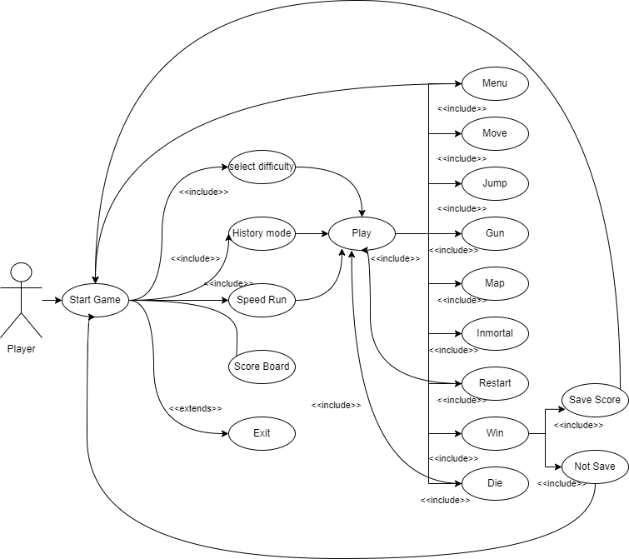

Data Base

For this project, since there's no need to store a vast amount of data, like only player names and scores, a database won't be necessary. Instead, I'll save the data in a .json file format. This approach allows for a lighter and more flexible management of information, suitable for the project's specific needs. Additionally, by not relying on a database server, we simplify the implementation and maintenance process.
Principio del formulario

TASKS

 | Duration | Start date | End date
Map design | 16 | 13/04 | 28/04
Main menu scene | 2 | 13/04 | 13/04
Training zone | 3 | 14/04 | 14/04
Level 3 | 1.5 | 15/04 | 15/04
Level 4 | 1.5 | 16/04 | 16/04
Level 5 | 1.5 | 19/04 | 19/04
Level 6 | 1.5 | 19/04 | 19/04
Final boss | 5 | 20/04 | 20/04
Quit game | 3 | 21/04 | 23/04
Graphical design | 1 | 21/04 | 21/04
Animation | 1 | 22/04 | 22/04
Functionality | 1 | 23/04 | 23/04
Guide map animation | 0.5 | 26/04 | 26/04
Gun shooting fixing | 0.5 | 26/04 | 26/04
Menu functionality | 5 | 27/04 | 27/04
Score board | 5 | 28/04 | 28/04
Score board design | 2 | 28/04 | 28/04
Functionality | 3 | 28/04 | 28/04
Make fruits more functional | 10 | 29/04 | 03/05
Game story | 10 | 04/05 | 05/05
Write the story | 2 | 04/05 | 04/05
Create the character | 2 | 04/05 | 04/05
Make it functional | 6 | 05/05 | 05/05
Check all works well | ? | 06/05 | 09/05

MONITORING AND EVALUATION
Throughout the project, I did not face significant technical difficulties. The new features I added to the project were implemented without major issues, thanks to careful planning and incremental testing. However, my major challenges stemmed from inadequate time management and the complexities involved in uploading the project to GitHub. I underestimated the amount of time each task would require, leading to a rushed schedule towards the end. Additionally, I encountered difficulties with GitHub, primarily related to version control and repository management, which further delayed progress. In the future, improving my time management skills and gaining a deeper understanding of GitHub will be essential to avoid these pitfall.

SOFTWARE IMPLEMENTATION INSTALLATION

Due to time constraints, I was unable to develop an installer for the application. As a result, the installation process is somewhat manual. To install and run the application, users need to clone my GitHub repository. This involves using Git to download the project's files from the repository. Once cloned, users must locate and execute the file named "ninja hop.exe" to start the game. This method, while not ideal, ensures that the application can be accessed and run as intended. In future projects, I plan to allocate time for creating a more user-friendly installer to streamline this process.

User guide

The user interface and controls of the game are designed to be intuitive, reducing the need for an extensive user guide. Here are the basic instructions to get started:

- Movement: Use the WASD keys or the arrow keys on your keyboard to move the character in the game.
- Jumping: Press the space bar to make the character jump.
- Shooting: Press the "G" key to fire the character's weapon.
- Immortal Mode: If you want to enable the immortal mode, which makes the character invincible, press the "I" key.
These simple controls are intended to make the game accessible to players of all skill levels. For any additional features or complex interactions, I may add more detailed instructions within the game's interface or in a future version of the user guide.

Conclusions
Reflecting on the project, I find myself dissatisfied with the overall outcome, primarily due to my poor time management and unrealistic assessment of task difficulties. Initially, I set ambitious goals without fully accounting for the complexity and time required to achieve them. This led to a rushed final phase where some aspects of the project were not as polished as I would have liked. Despite these setbacks, I am pleased with the sections of the project that I completed. The features that were implemented function well and meet the initial specifications. This experience has highlighted the importance of realistic planning and time allocation in project management. Moving forward, I will focus on improving these skills to enhance the quality and completion of my future projects. Additionally, I have gained valuable insights into version control with GitHub, which will be beneficial in managing future projects more efficiently.

